BÀI THỰC HÀNH TUẦN 2 LAB 4
Họ và tên: Đặng Đình An
Lớp 11_THMT
MSSV:1150080001
II. Luyện tập Lab4
Bài 1: Bài tập 1: Trong bài luyện tập 1, viết code cho phép khi nhấn nút Login thì sẽ hiện Toast: “Bạn đã đăng nhập thành công với email: … và mật khẩu ….”.
activity_login.xml
<?xml version="1.0" encoding="utf-8"?>
<LinearLayout xmlns:android="http://schemas.android.com/apk/res/android"
android:orientation="vertical"
android:layout_width="match_parent"
android:layout_height="match_parent"
android:background="@color/gray">
<FrameLayout
android:layout_width="match_parent"
android:layout_height="300dp">
<View
android:layout_width="match_parent"
android:layout_height="300dp"
android:background="@drawable/bg_top"/>
<TextView
android:layout_width="wrap_content"
android:layout_height="wrap_content"
android:layout_gravity="end"
android:layout_marginTop="220dp"
android:layout_marginEnd="30dp"
android:text="@string/login"
android:textColor="@color/white"
android:textSize="20sp"/>
</FrameLayout>
<EditText
android:id="@+id/edtEmail"
android:layout_width="match_parent"
android:layout_height="50dp"
android:layout_marginHorizontal="30dp"
android:layout_marginTop="50dp"
android:background="@drawable/bg_radius"
android:hint="@string/email"
android:padding="10dp"
android:textSize="18sp"/>
<EditText
android:id="@+id/edtPassword"
android:layout_width="match_parent"
android:layout_height="50dp"
android:layout_marginHorizontal="30dp"
android:layout_marginTop="20dp"
android:background="@drawable/bg_radius"
android:hint="@string/password"
android:padding="10dp"
android:textSize="18sp"/>
<TextView
android:layout_width="wrap_content"
android:layout_height="wrap_content"
android:layout_gravity="end"
android:layout_marginTop="10dp"
android:layout_marginEnd="30dp"
android:text="@string/forgot_pass"
android:textColor="@color/black"
android:textSize="14sp"/>
<TextView
android:id="@+id/tvLogin"
android:layout_width="match_parent"
android:layout_height="50dp"
android:layout_marginHorizontal="30dp"
android:layout_marginTop="50dp"
android:background="@drawable/bg_login"
android:gravity="center"
android:text="@string/login"
android:textColor="@color/white"
android:textSize="18sp"/>
</LinearLayout>
LoginActivity.java
package com.example.lab4;
import android.content.Intent;
import android.os.Bundle;
import android.view.LayoutInflater;
import android.view.View;
import android.widget.EditText;
import android.widget.TextView;
import android.widget.Toast;
import androidx.appcompat.app.AppCompatActivity;
public class LoginActivity extends AppCompatActivity {
EditText edtEmail, edtPassword;
TextView tvLogin;
@Override
protected void onCreate(Bundle savedInstanceState) {
super.onCreate(savedInstanceState);
setContentView(R.layout.activity_login);
edtEmail = findViewById(R.id.edtEmail);
edtPassword = findViewById(R.id.edtPassword);
tvLogin = findViewById(R.id.tvLogin);
tvLogin.setOnClickListener(v -> {
String email = edtEmail.getText().toString();
String pass = edtPassword.getText().toString();
// Custom Toast
View layout = LayoutInflater.from(this).inflate(R.layout.bg_radius, null);
Toast toast = new Toast(this);
toast.setView(layout);
toast.setDuration(Toast.LENGTH_LONG);
toast.show();
// Mở MenuActivity
Intent intent = new Intent(LoginActivity.this, MenuActivity.class);
startActivity(intent);
});
}
}
Kết quả
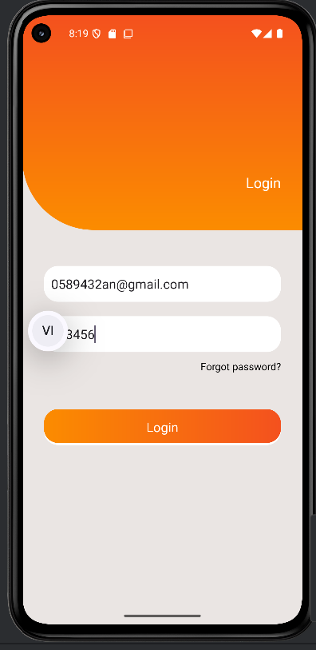
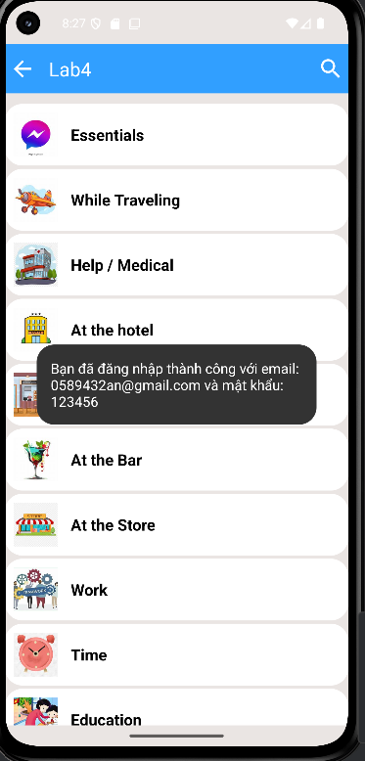
Bài tập 2:
MenuActivity.java
package com.example.lab4;
import android.content.Intent;
import android.os.Bundle;
import android.view.LayoutInflater;
import android.view.View;
import android.widget.ImageView;
import android.widget.LinearLayout;
import android.widget.TextView;
import android.widget.Toast;
import androidx.appcompat.app.AppCompatActivity;
import java.util.ArrayList;
import java.util.Arrays;
import java.util.HashMap;
import java.util.List;
import java.util.Map;
public class MenuActivity extends AppCompatActivity {
private static final int[] ID_DRAWABLES = {
R.drawable.ic_mess, R.drawable.ic_flight, R.drawable.ic_hospital,
R.drawable.ic_hotel, R.drawable.ic_restaurant, R.drawable.ic_coctail,
R.drawable.ic_store, R.drawable.ic_work, R.drawable.ic_time,
R.drawable.ic_education, R.drawable.ic_movie
};
private static final int[] ID_TEXTS = {
R.string.txt_mess, R.string.txt_flight, R.string.txt_hospital,
R.string.txt_hotel, R.string.txt_restaurant, R.string.txt_coctail,
R.string.txt_store, R.string.txt_work, R.string.txt_time,
R.string.txt_education, R.string.txt_movie
};
private Map<String, List<String>> vocabularyMap = new HashMap<>();
@Override
protected void onCreate(Bundle savedInstanceState) {
super.onCreate(savedInstanceState);
setContentView(R.layout.activity_menu);
// Sample words
vocabularyMap.put(getString(R.string.txt_mess), Arrays.asList("Hello", "Goodbye", "Thanks"));
vocabularyMap.put(getString(R.string.txt_flight), Arrays.asList("Ticket", "Airport", "Hotel"));
vocabularyMap.put(getString(R.string.txt_hospital), Arrays.asList("Doctor", "Medicine", "Hospital"));
// Các chủ đề khác nếu muốn, thêm tương tự
LinearLayout lnMain = findViewById(R.id.lnMain);
for (int i = 0; i < ID_DRAWABLES.length; i++) {
View v = LayoutInflater.from(this).inflate(R.layout.item_topic, null);
ImageView ivTopic = v.findViewById(R.id.ivTopic);
TextView tvTopic = v.findViewById(R.id.tvTopic);
ivTopic.setImageResource(ID_DRAWABLES[i]);
tvTopic.setText(ID_TEXTS[i]);
int index = i;
v.setOnClickListener(view -> {
String topic = getString(ID_TEXTS[index]);
List<String> words = vocabularyMap.getOrDefault(topic, new ArrayList<>());
Toast.makeText(this, "Chủ đề " + topic + " có " + words.size() + " từ vựng", Toast.LENGTH_SHORT).show();
Intent intent = new Intent(MenuActivity.this, TopicActivity.class);
intent.putStringArrayListExtra("words", new ArrayList<>(words));
intent.putExtra("topic", topic);
startActivity(intent);
});
// Thêm margin giữa các item
LinearLayout.LayoutParams params = new LinearLayout.LayoutParams(
LinearLayout.LayoutParams.MATCH_PARENT,
LinearLayout.LayoutParams.WRAP_CONTENT
);
params.setMargins(0, 5, 0, 5);
v.setLayoutParams(params);
lnMain.addView(v);
}
}
}
activity_menu.xml
<LinearLayout xmlns:android="http://schemas.android.com/apk/res/android"
xmlns:app="http://schemas.android.com/apk/res-auto"
android:orientation="vertical"
android:layout_width="match_parent"
android:layout_height="match_parent"
android:background="@color/gray"
android:fitsSystemWindows="true"
android:padding="10dp">
<!-- ActionBar tự tạo -->
<LinearLayout
android:layout_width="match_parent"
android:layout_height="56dp"
android:orientation="horizontal"
android:background="@color/purple_200"
android:gravity="center_vertical">
<ImageView
android:id="@+id/ivBack"
android:layout_width="40dp"
android:layout_height="40dp"
android:src="@drawable/ic_back"
android:padding="5dp"
android:contentDescription="Back"
app:tint="@color/white" />
<TextView
android:id="@+id/tvTitle"
android:layout_width="0dp"
android:layout_height="match_parent"
android:layout_weight="1"
android:text="@string/app_name"
android:textSize="22sp"
android:textColor="@color/white"
android:gravity="center_vertical"
android:paddingStart="10dp"/>
<ImageView
android:id="@+id/ivSearch"
android:layout_width="40dp"
android:layout_height="40dp"
android:src="@drawable/ic_search"
android:padding="5dp"
android:contentDescription="Search"
app:tint="@color/white" />
</LinearLayout>
<!-- ScrollView chứa danh sách chủ đề -->
<ScrollView
android:layout_width="match_parent"
android:layout_height="match_parent"
android:layout_marginTop="10dp">
<LinearLayout
android:id="@+id/lnMain"
android:layout_width="match_parent"
android:layout_height="wrap_content"
android:orientation="vertical"/>
</ScrollView>
</LinearLayout>
Kết quả
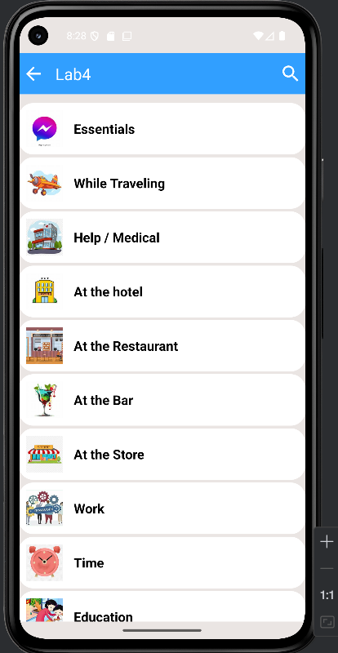

activity_topic.xml
<?xml version="1.0" encoding="utf-8"?>
<ListView xmlns:android="http://schemas.android.com/apk/res/android"
android:id="@+id/lvWords"
android:fitsSystemWindows="true"
android:layout_width="match_parent"
android:layout_height="match_parent"/>
TopicActivity.java
package com.example.lab4;
import android.os.Bundle;
import android.widget.ArrayAdapter;
import android.widget.ListView;
import androidx.appcompat.app.AppCompatActivity;
import java.util.List;
public class TopicActivity extends AppCompatActivity {
@Override
protected void onCreate(Bundle savedInstanceState) {
super.onCreate(savedInstanceState);
setContentView(R.layout.activity_topic);
ListView lvWords = findViewById(R.id.lvWords);
List<String> words = getIntent().getStringArrayListExtra("words");
String topic = getIntent().getStringExtra("topic");
setTitle(topic);
ArrayAdapter<String> adapter = new ArrayAdapter<>(this,
android.R.layout.simple_list_item_1, words);
lvWords.setAdapter(adapter);
}
}
Kết quả
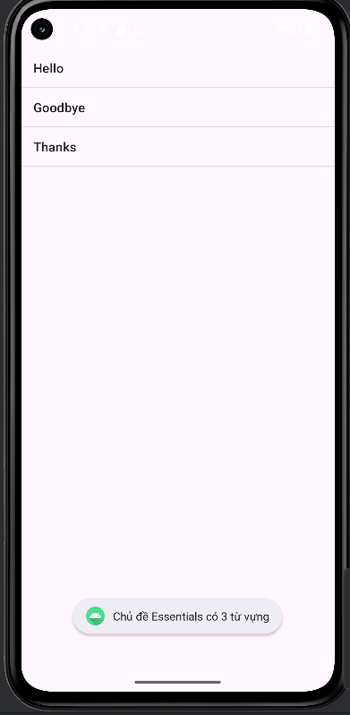
Bài 3:
MenuActity.java( cập nhật)
package com.example.lab4;
import android.content.Intent;
import android.os.Bundle;
import android.view.LayoutInflater;
import android.view.View;
import android.widget.Button;
import android.widget.ImageView;
import android.widget.LinearLayout;
import android.widget.TextView;
import android.widget.Toast;
import androidx.appcompat.app.AppCompatActivity;
import java.util.ArrayList;
import java.util.Arrays;
import java.util.Collections;
import java.util.HashMap;
import java.util.List;
import java.util.Map;
public class MenuActivity extends AppCompatActivity {
private static final int[] ID_DRAWABLES = {
R.drawable.ic_mess, R.drawable.ic_flight, R.drawable.ic_hospital,
R.drawable.ic_hotel, R.drawable.ic_restaurant, R.drawable.ic_coctail,
R.drawable.ic_store, R.drawable.ic_work, R.drawable.ic_time,
R.drawable.ic_education, R.drawable.ic_movie
};
private static final int[] ID_TEXTS = {
R.string.txt_mess, R.string.txt_flight, R.string.txt_hospital,
R.string.txt_hotel, R.string.txt_restaurant, R.string.txt_coctail,
R.string.txt_store, R.string.txt_work, R.string.txt_time,
R.string.txt_education, R.string.txt_movie
};
Map<String, List<String>> vocabularyMap = new HashMap<>();
LinearLayout lnMain;
Button btnRandomIcons;
@Override
protected void onCreate(Bundle savedInstanceState) {
super.onCreate(savedInstanceState);
setContentView(R.layout.activity_menu);
lnMain = findViewById(R.id.lnMain);
btnRandomIcons = findViewById(R.id.btnRandomIcons);
// Sample vocabulary
vocabularyMap.put(getString(R.string.txt_mess), Arrays.asList("Hello", "Goodbye", "Thanks"));
vocabularyMap.put(getString(R.string.txt_flight), Arrays.asList("Ticket", "Airport", "Hotel"));
// Lấy và hiển thị tất cả icon lần đầu
showIcons(ID_DRAWABLES, ID_TEXTS);
// Bấm nút Random Icons
btnRandomIcons.setOnClickListener(v -> {
// Random 10 icon
List<Integer> drawableList = new ArrayList<>();
List<Integer> textList = new ArrayList<>();
for (int i = 0; i < ID_DRAWABLES.length; i++) {
drawableList.add(ID_DRAWABLES[i]);
textList.add(ID_TEXTS[i]);
}
// Trộn danh sách
Collections.shuffle(drawableList);
Collections.shuffle(textList);
// Lấy 10 phần tử đầu
int[] randomDrawables = new int[10];
int[] randomTexts = new int[10];
for (int i = 0; i < 10; i++) {
randomDrawables[i] = drawableList.get(i);
randomTexts[i] = textList.get(i);
}
// Hiển thị
showIcons(randomDrawables, randomTexts);
});
}
private void showIcons(int[] drawables, int[] texts) {
lnMain.removeAllViews();
for (int i = 0; i < drawables.length; i++) {
View v = LayoutInflater.from(this).inflate(R.layout.item_topic, null);
ImageView ivTopic = v.findViewById(R.id.ivTopic);
TextView tvTopic = v.findViewById(R.id.tvTopic);
ivTopic.setImageResource(drawables[i]);
tvTopic.setText(texts[i]);
int index = i;
tvTopic.setOnClickListener(view -> {
String topic = getString(texts[index]);
List<String> words = vocabularyMap.get(topic);
if (words == null) words = Arrays.asList();
Toast.makeText(this, "Chủ đề " + topic + " có " + words.size() + " từ vựng", Toast.LENGTH_SHORT).show();
Intent intent = new Intent(MenuActivity.this, TopicActivity.class);
intent.putStringArrayListExtra("words", new ArrayList<>(words));
intent.putExtra("topic", topic);
startActivity(intent);
});
lnMain.addView(v);
}
}
}
activity_menu.xml(cập nhật)
<LinearLayout xmlns:android="http://schemas.android.com/apk/res/android"
xmlns:app="http://schemas.android.com/apk/res-auto"
android:orientation="vertical"
android:layout_width="match_parent"
android:layout_height="match_parent"
android:background="@color/gray"
android:fitsSystemWindows="true"
android:padding="10dp">
<!-- ActionBar tự tạo -->
<LinearLayout
android:layout_width="match_parent"
android:layout_height="56dp"
android:orientation="horizontal"
android:background="@color/purple_200"
android:gravity="center_vertical">
<ImageView
android:id="@+id/ivBack"
android:layout_width="40dp"
android:layout_height="40dp"
android:src="@drawable/ic_back"
android:padding="5dp"
android:contentDescription="Back"
app:tint="@color/white" />
<TextView
android:id="@+id/tvTitle"
android:layout_width="0dp"
android:layout_height="match_parent"
android:layout_weight="1"
android:text="@string/app_name"
android:textSize="22sp"
android:textColor="@color/white"
android:gravity="center_vertical"
android:paddingStart="10dp"/>
<ImageView
android:id="@+id/ivSearch"
android:layout_width="40dp"
android:layout_height="40dp"
android:src="@drawable/ic_search"
android:padding="5dp"
android:contentDescription="Search"
app:tint="@color/white" />
</LinearLayout>
<Button
android:id="@+id/btnRandomIcons"
android:layout_width="match_parent"
android:layout_height="50dp"
android:layout_margin="10dp"
android:text="Random Icons"
android:background="@color/purple_500"
android:textColor="@android:color/white"
android:textSize="18sp"/>
<!-- ScrollView chứa danh sách chủ đề -->
<ScrollView
android:layout_width="match_parent"
android:layout_height="match_parent"
android:layout_marginTop="10dp">
<LinearLayout
android:id="@+id/lnMain"
android:layout_width="match_parent"
android:layout_height="wrap_content"
android:orientation="vertical"/>
</ScrollView>
</LinearLayout>

Kết quả:
